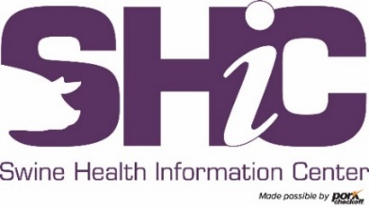

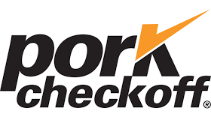

INSTRUCTIONS & FORMAT

Request For Research Proposals

H5N1 Risk to Swine Research Program

January 29, 2026

Thank you for your interest in the Research Program of the Swine Health Information Center, the Foundation for Food & Agriculture Research, and the Pork Checkoff! Please read the following instructions completely.

COMPLETE PROPOSAL
- The proposal must be typed in the required format on the following page.
- Your proposal must be typed in 12-point font size, Times New Roman font, with margins of 0.5-inch on left, right, top and bottom.
- Proposals should be submitted with all required documents as a SINGLE WORD file – not PDF.
- PLEASE REMEMBER TO TURN OFF TRACKING CHANGES BEFORE SUBMITTING THE PROPOSAL!

Save your proposal with the file name of: “LAST NAME, FIRST INITIAL – Title of Proposal”. Example: SMITH,J – Proposal.doc. If you are submitting more than one proposal, please use SMITH,R-2 – Proposal.doc.

Proposals should be emailed to research@swinehealth.org and are due for this RFP by:

5:00 PM CT on March 24, 2026

PLEASE DELETE THIS PAGE OF INSTRUCTIONS BEFORE YOU SUBMIT YOUR PROPOSAL.

THANK YOU

PROPOSAL TEMPLATE
(Next three pages)

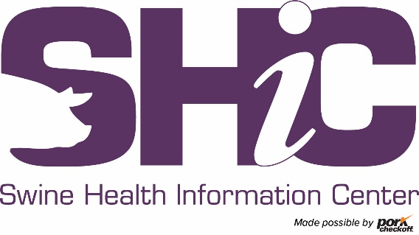
Swine Health Information Center Research Proposal
H5N1 Risk to Swine Research Program
Proposal Cover Page

It is our policy to honor the confidentiality of each research proposal to protect investigators from having their ideas exposed to unnecessary critique and discussion. However, during review, the reviewer may make discreet inquiries on protocol mechanics if it improves the quality of his/her evaluation, so long as the source and nature of the work is undisclosed.

Project # |  |  |  |  | (SHIC use only)
Category: | SHIC/FFAR/NPB H5N1 Risk to Swine Research Program
Project Title:

Requested Funding Amount: |  |  |  |  |  | Project Duration:
Principal Investigator and Title:
Institution:
Address:

City, ST ZIP
Phone: |  |  |  |  |  | FAX:
Email:

Co-Investigator(s) | Institution, City, State | Email address
1.
2.
3.
4.
5.

Contracts/Grants Administrator
Name:
(person to receive contracts, if funded)
 | Title |  |  |  |  |  |  |  | Organization
 | Address
 | City |  |  |  |  |  |  |  |  | State |  |  |  | ZIP
 | Phone |  |  |  |  | Fax |  |  |  |  |  | E-Mail
I (Principal Investigator) certify that the Grants and Contracts Administrator has reviewed this proposal prior to its submission to the Swine Health Information Center for possible funding.

Please limit the proposal body to five pages, single spaced, using 12-point Times New Roman font, in addition to the cover page and budget page.
The Swine Health Information Center, Foundation for Food & Agriculture Research, and Pork Checkoff will use this description to help assign a priority to the proposal after it has been reviewed by experts for scientific soundness and to communicate the objective of the research to a lay audience. Please be complete, concise, and convey your answers in a manner appropriate for the audience.

  - Project Introduction and Objectives – provide a brief introduction that includes project rationale, which of the SHIC/FFAR/NPB H5N1 Risk to Swine research priorities are being addressed, and a separate list of objectives for a concise explanation of the research questions to be answered.

  - Research Design to Achieve these Objectives – clearly and comprehensively state the details of Experimental Design and Methods, including how procedures will specifically address proposal objectives. Discuss and reference all assays, procedures, and statistical tests used in the study. This section is critical for reviewing scientific merit and the ability to draw meaningful conclusions from data.

  - Description of Quality Assurance/Quality Control Plan - QA/QC refers to procedures and protocols that investigators have in place to ensure their measurements are accurate (the absolute true value), reproducible (precise, consistent), and include uncertainty estimates. In the regulatory arena, this aspect of data collection and analysis is crucial to research outcomes. It specifically involves following established rules in the field and laboratory for assurance that the sample is representative of the population or site.

  - Schedule/Timeline for Proposed Research.

  - Certification - most institutions require approval of proposals before submission. Please indicate this step has been completed by supplying the names, title, email address and phone number of the personnel from the grants office, college and department who have approved your proposal for submission. PROPOSALS MAY BE REJECTED IF THIS INFORMATION IS NOT INCLUDED.

  - Budget for Project (See Template) - overhead and indirect costs are typically NOT covered by the Swine Health Information Center research funds. Graduate student support, student and other hourly labor, and post-doctoral support will be allowed. Partial support for principal investigators (PI) on less than 12-month salaried appointments will be allowed if a detailed budget narrative addressing the amount of requested support in relation to the PI project time commitment justifies the expense. Equipment is not typically allowed unless explained in the proposal, included in the budget, and approved in advance by SHIC.
Budget Format –
- Costs MUST be indicated in a four-column format with SHIC, Institutional Support, Other Support, and Total columns.
- Other funding requested or anticipated as matching support for this project must be indicated in an additional budget column.

  - Letters of Cooperation from Project Co-Investigators and Other Collaborators - included in addition to the five-page proposal plus cover page and budget page.
Budget (add lines as required):
Category | Description (if needed) | SHIC | Institution Support | Other Support | Total
1) Personnel (include name where appropriate)
2) Contracted Services (diagnostic fees, computer access, etc.)
3) Assay and Testing Fees (“per sample” costs not included under Supplies)
4) Travel
5) Equipment (non-disposable items, please contact SHIC if greater than $500)
6) Supplies (disposable items and reagents)
7) Animal Cost (list only net cost if animals will be salvaged)
8) Animal Care (per diem care, housing, and feed)
9) Shipping, Handling, Mailing Expenses
10) Other expenses (list)
11) Indirect Cost Recovery (SHIC does not pay IDC, please contact SHIC with questions)
12) TOTAL
Explanation (if required):

